**SEP System Architecture and Setup**

**Current Lab Setup**

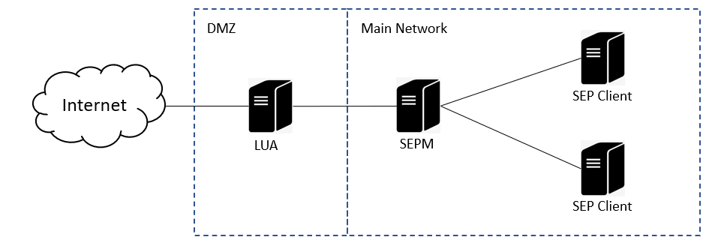

Components:

1. LiveUpdate Administrator (LUA)
2. Symantec Endpoint Protection Manager (SEPM)
3. Symantec Endpoint Protection Client (SEP)

**LiveUpdate Administrator (LUA)**

**LUA** is an enterprise web application that lets you manage Symantec updates on an internal LiveUpdate (LU) server.  LUA can be configured to download content for various products such as SEP, DCS, SMS, SPE, etc.  LUA retrieves content from an external Symantec LU server to be published to Distribution Centers where clients can download from.  Content can also be sent to a Testing Distribution Center before publishing so content can be vetted before being released to the entire environment.